SUPPLEMENTARY MATERIAL

Morphologic and genomic analyses of new isolates reveal a second lineage of cedratviruses

Authors:
Rodrigo Araújo Lima Rodrigues^{1,2†}; Julien Andreani^{1†}; Ana Cláudia Andrade²; Talita Machado²; Souhila Abdi¹, Enora Tomei¹, Caroline Michele¹, Anthony Levasseur¹; Jônatas Santos Abrahão²; Bernard La Scola¹*

Affiliation:
¹Aix Marseille Université, IRD, APHM, MEPHI, IHU-Méditerranée Infection, Marseille, France
²Laboratório de Vírus, Departamento de Microbiologia, Instituto de Ciências Biológicas, Universidade Federal de Minas Gerais, Belo Horizonte, Minas Gerais, Brazil

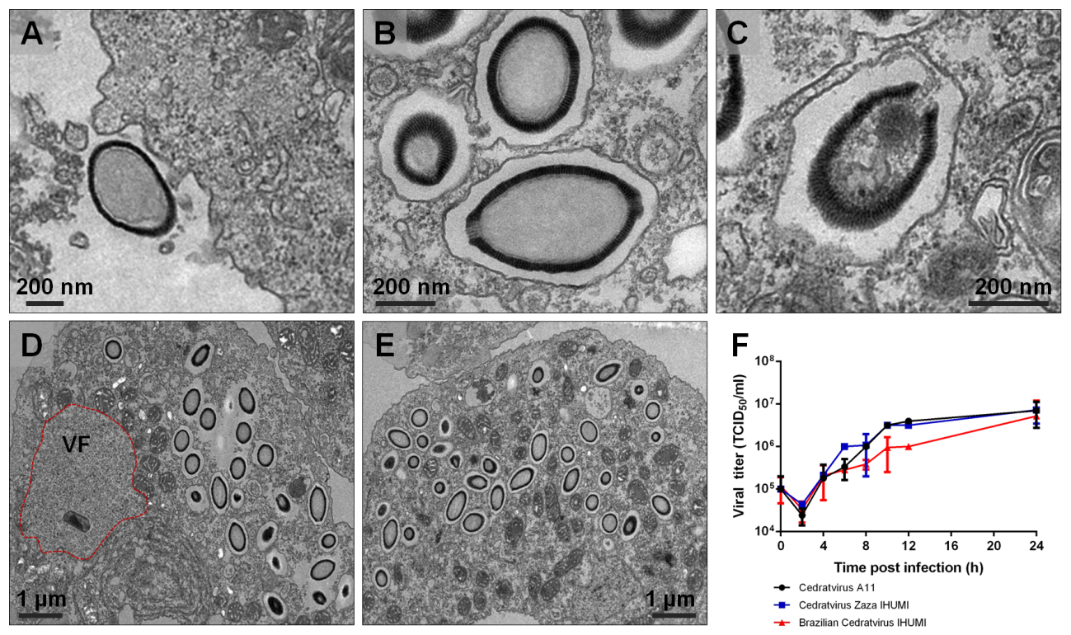
Supplementary Figure 1: Ultrathin sections of Brazilian Cedratvirus IHUMI asynchronous replication cycle. (A) Virus attached to the surface of Acanthamoeba castellanii cell; (B) Viral particles inside vacuoles after entry through phagocytosis; (C) Opening of the cork and releasing of interior content into the host cytoplasm (D) Viral factory (VF) containing immature particles in formation while some mature particles are seem in the host cytoplasm; (E) Accumulation of assembled virions throughout the host cell. Scale bars are indicated on each panel. (F) One-step growth curve of different cedratviruses, evidencing the same profile of replicative cycle.

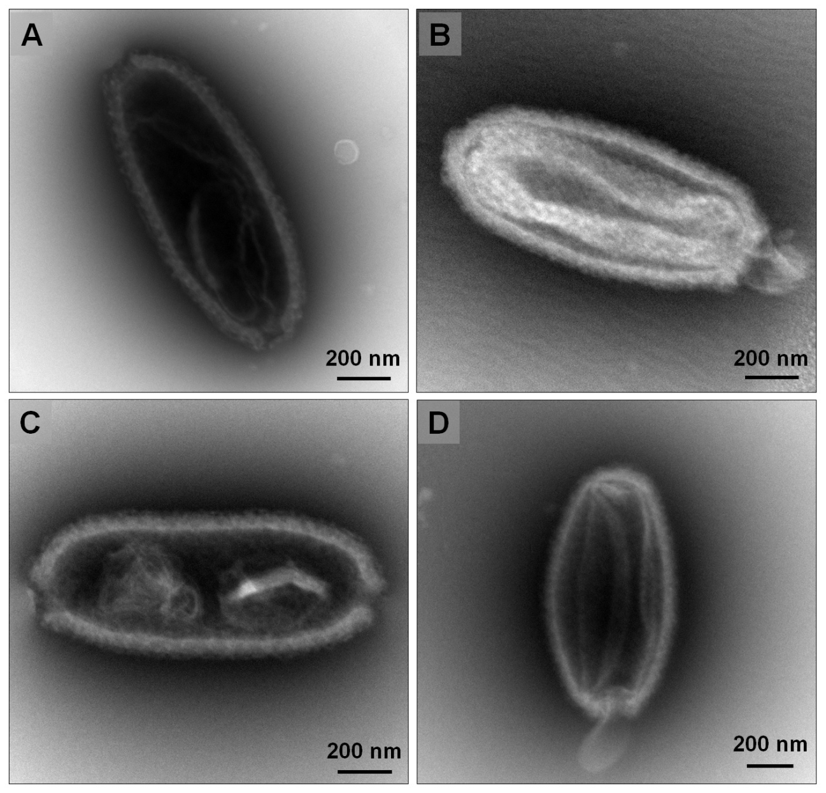
Supplementary Figure 2: (A-D) Negative staining imagens of different viral particles exhibiting membranous structures inside the capsid. Similar features were also observed for Pithovirus sibericum.

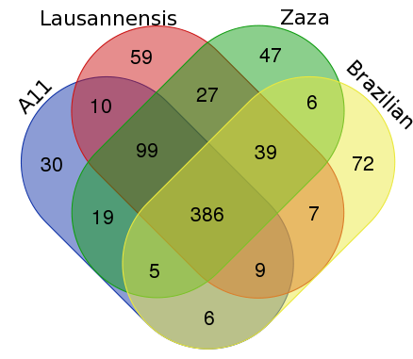

Supplementary figure 3: Venn diagram comparison of best reciprocal hit obtained belonging to the predicted proteins of different cedratviruses. ‘A11’ represents Cedratvirus A11; ‘Lausannensis’ represents Cedratvirus lausannensis; ‘Zaza’ represents Cedratvirus Zaza IHUMI and ‘Brazilian’ represents Brazilian Cedratvirus IHUMI. The diagram was created online (http://bioinformatics.psb.ugent.be/webtools/Venn/).

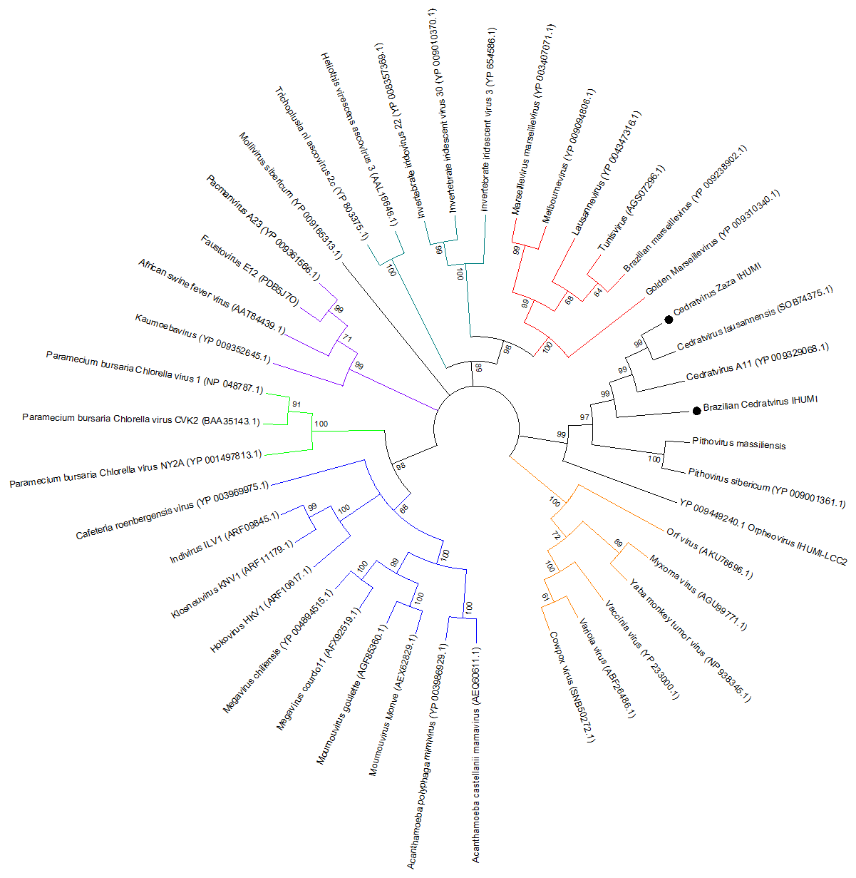

Supplementary figure 4: Phylogenetic tree based on Major Capsid Protein amino acid sequences of nucleo-cytoplasmic large DNA viruses (NCLDVs). The tree was constructed by using MEGA version 6.0, applying the maximum likelihood method and JTT model of evolution with 1000 bootstrap replicates. Colors indicate viral families: blue was used for Mimiviridae; green for Phycodnaviridae; red for Marseilleviridae; ocean blue for Iridoviridae/Ascoviridae; purple for extended Asfarviridae; orange for Poxviridae. The new cedratviruses are highlighted with black circles. Scale bar indicates rate of evolution.

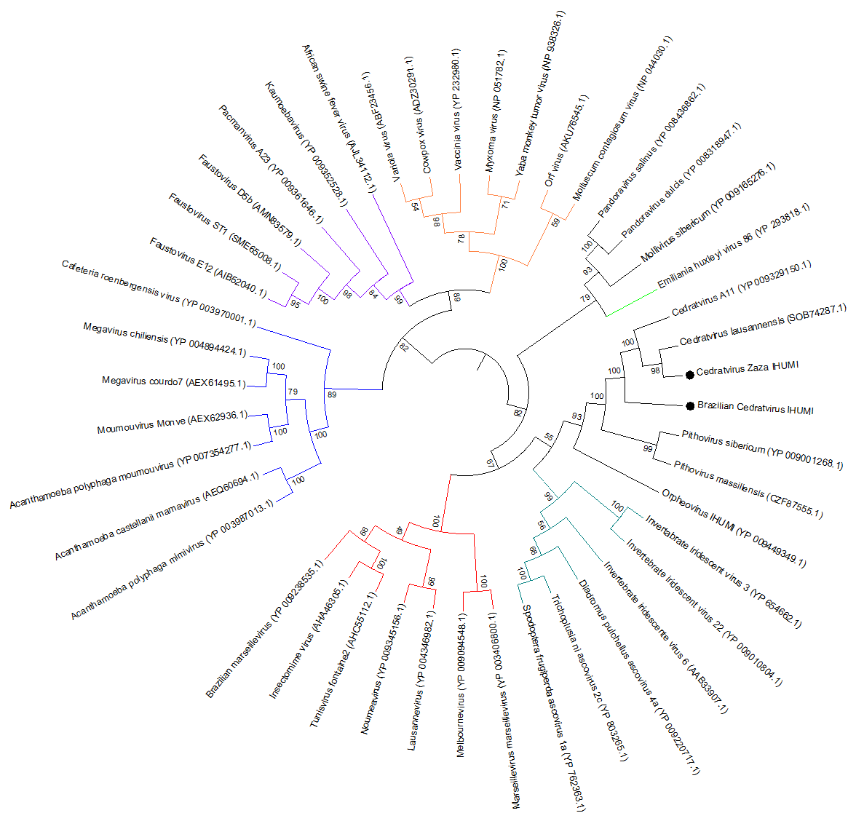

Supplementary figure 5: Phylogenetic tree based on DNA-dependent RNA polymerase subunit 1 (RPB1) amino acid sequences of nucleo-cytoplasmic large DNA viruses (NCLDVs). The tree was constructed by using MEGA version 6.0, applying the maximum likelihood method and JTT model of evolution with 1000 bootstrap replicates. Colors indicate viral families: blue was used for Mimiviridae; green for Phycodnaviridae; red for Marseilleviridae; ocean blue for Iridoviridae/Ascoviridae; purple for extended Asfarviridae; orange for Poxviridae. The new cedratviruses are highlighted with black circles. Scale bar indicates rate of evolution.

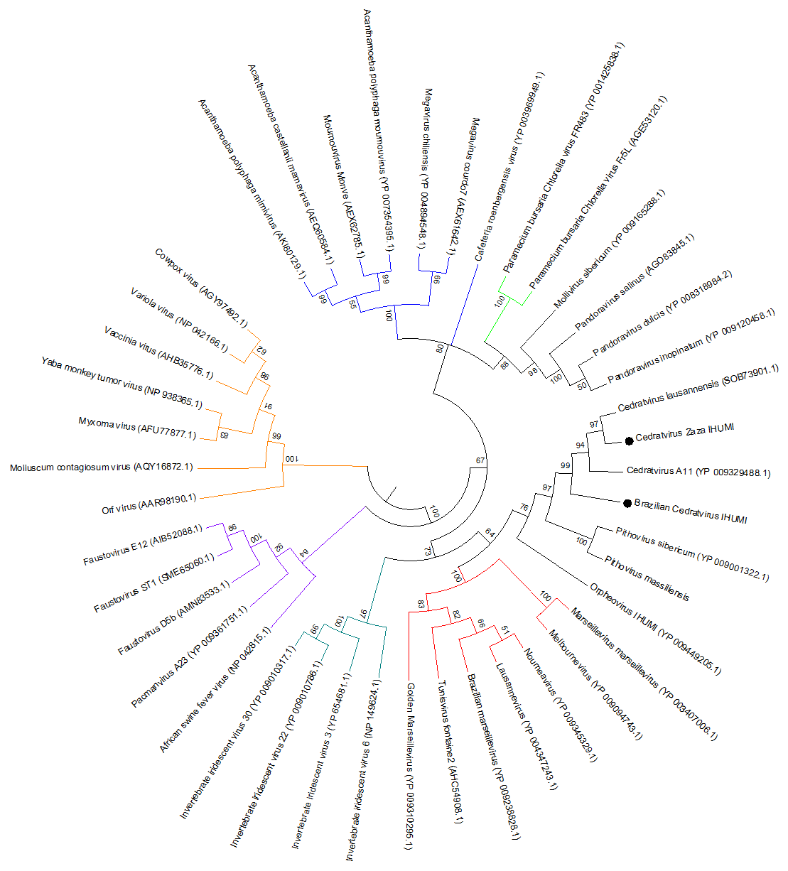

Supplementary figure 6: Phylogenetic tree based on VV-A18 helicase amino acid sequences of nucleo-cytoplasmic large DNA viruses (NCLDVs). The tree was constructed by using MEGA version 6.0, applying the maximum likelihood method and JTT model of evolution with 1000 bootstrap replicates. Colors indicate viral families: blue was used for Mimiviridae; green for Phycodnaviridae; red for Marseilleviridae; ocean blue for Iridoviridae/Ascoviridae; purple for extended Asfarviridae; orange for Poxviridae. The new cedratviruses are highlighted with black circles. Scale bar indicates rate of evolution.

Supplementary Table 1: Morphological and genomic data of nucleo-cytoplasmic large DNA viruses used in the study.

Viral group | Virus | Structure | Virion size (nm) | Genome length (kbp) | Method | Virion volume (nm³) | Reference
Mimiviridae | Acanthamoeba polyphaga mimivirus | Icosahedral | 500 | 1182 | CryoEM | 6,54E+07 | (1)
Mimiviridae | Cafeteria roenbergensis virus | Icosahedral | 300 | 617 | CryoEM | 1,41E+07 | (2)
Marseilleviridae | Marseillevirus marseillevirus | Icosahedral | 250 | 368 | CryoEM | 8,18E+06 | (3)
Marseilleviridae | Melbournevirus | Icosahedral | 230 | 369 | CryoEM | 6,37E+06 | (4)
Faustovirus | Faustovirus E12 | Icosahedral | 240 | 466 | CryoEM | 7,24E+06 | (5)
Kaumoebavirus | Kaumoebavirus | Icosahedral | 250 | 351 | Negative stainning | 8,18E+06 | (6)
Pacmanvirus | Pacmanvirus A23 | Icosahedral | 250 | 395 | CryoEM | 8,18E+06 | (7)
Pithovirus | Pithovirus sibericum | Ovoid | 1530x810 | 610 | CryoEM | 9,92E+08 | (8)
Pithovirus | Pithovirus massiliensis | Ovoid | 1400x500 | 683 | Negative stainning | 5,13E+08 | (9)
Cedratvirus | Cedratvirus A11 | Ovoid | 1280x550 | 590 | Negative stainning | 4,80E+08 | This study
Cedratvirus | Cedratvirus Zaza IHUMI | Ovoid | 1110x580 | 560 | Negative stainning | 3,79E+08 | This study
Cedratvirus | Brazilian Cedratvirus IHUMI | Ovoid | 910x510 | 460 | Negative stainning | 2,26E+08 | This study
Orpheovirus | Orpheovirus IHUMI-LCC2 | Ovoid | 1000x500 | 1473 | Negative stainning | 2,62E+08 | (10)
Phycodnaviridae | Paramecium Bursaria Chlorella Virus 1 | Icosahedral | 190 | 330 | CryoEM | 3,59E+06 | (11)
Iridoviridae | Chilo iridescent virus | Icosahedral | 185 | 212 | CryoEM | 3,31E+06 | (12)

References
1. Xiao C, Kuznetso YG, Sun S, Hafenstein SL, Kostyuchenko VA, Chipman PR, Suzan-Monti M, Raoult D, McPherson A, Rossmann MG. 2009. Structural studies of the giant Mimivirus. PLoS Biol 7:0958–0966.
2. Xiao C, Fischer MG, Bolotaulo DM, Ulloa-Rondeau N, Avila GA, Suttle CA. 2017. Cryo-EM reconstruction of the Cafeteria roenbergensis virus capsid suggests novel assembly pathway for giant viruses. Sci Rep 7:1–7.
3. Boyer M, Yutin N, Pagnier I, Barrassi L, Fournous G, Espinosa L, Robert C, Azza S, Sun S, Rossmann MG, Suzan-Monti M, La Scola B, Koonin E V, Raoult D. 2009. Giant Marseillevirus highlights the role of amoebae as a melting pot in emergence of chimeric microorganisms. Proc Natl Acad Sci U S A 106:21848–21853.
4. Okamoto K, Miyazaki N, Reddy HKN, Hantke MF, Maia FRNC, Larsson DSD, Abergel C, Claverie JM, Hajdu J, Murata K SM. 2018. Cryo-EM structure of a Marseilleviridae virus particle reveals a large internal microassemblye. Virology 516:239–245.
5. Klose T, Reteno DG, Benamar S, Hollerbach A, Colson P, La Scola B, Rossmann MG. 2016. Structure of faustovirus, a large dsDNA virus. Proc Natl Acad Sci 113:6206–6211.
6. Bajrai LH, Benamar S, Azhar EI, Robert C, Levasseur A, Raoult D, La Scola B. 2016. Kaumoebavirus, a new virus that clusters with Faustoviruses and Asfarviridae. Viruses 8.
7. Andreani J, Khalil JYB, Sevvana M, Benamar S, Di Pinto F, Bitam I, Colson P, Klose T, Rossmann MG, Raoult D, La Scola B. 2017. Pacmanvirus, a New Giant Icosahedral Virus at the Crossroads between Asfarviridae and Faustoviruses. J Virol 91:e00212-17.
8. Okamoto K, Miyazaki N, Song C, Maia FRNC, Reddy HKN, Abergel C, Claverie JM, Hajdu J, Svenda M, Murata K. 2017. Structural variability and complexity of the giant Pithovirus sibericum particle revealed by high-voltage electron cryo-Tomography and energy-filtered electron cryo-microscopy. Sci Rep 7:1–12.
9. Levasseur A, Andreani J, Delerce J, Bou Khalil J, Robert C, La Scola B, Raoult D. 2016. Comparison of a Modern and Fossil Pithovirus Reveals Its Genetic Conservation and Evolution. Genome Biol Evol 8:2333–2339.
10. Andreani J, Khalil JYB, Baptiste E, Hasni I, Michelle C, Raoult D, Levasseur A, La Scola B. 2018. Orpheovirus IHUMI-LCC2: A New Virus among the Giant Viruses. Front Microbiol 8:1–11.
11. Nandhagopal N, Simpson AA, Gurnon JR, Yan X, Baker TS, Graves M V., Van Etten JL, Rossmann MG. 2002. The structure and evolution of the major capsid protein of a large, lipid-containing DNA virus. Proc Natl Acad Sci U S A 99:14758–63.
12. Yan X, Chipman PR, Battisti AJ, Bergoin M, Rossmann MG, Baker TS. 2005. The structure of the T=147 iridovirus, CIV, at 13Å resolution, p. 134–135. In Microscopy and Microanalysis.

